Q3. (a) Select any MP3 song of your choice and process it using a low-pass filter that you design. Experiment with at least three different cutoff frequencies and observe how each setting changes the filtered audio output. Discuss your observations in detail, focusing on how the cutoff frequency influences the clarity, tonal balance, and overall character of the song. (CO2, CO3, CO5)
(b) Use an appropriate band-pass filter to separately suppress vocals and background music, saving each filtered result as its own MP3 file. Analyze and describe your observations, focusing on how each filter affects the different components of the song.

Code:-
import librosa
import librosa.display
import numpy as np
import matplotlib.pyplot as plt
import soundfile as sf
from scipy.signal import butter, sosfiltfilt

# --- 1. Load Audio File ---
folder = 'D:\\ict\\sem5\\DSIP\\lab & theory session\\assignmentAndOEQ\\OPQ_4\\'
filename = folder + 'song.mp3'
y, sr = librosa.load(filename, sr=None)
print(f"Sample rate: {sr}, Duration: {len(y)/sr:.2f} seconds")

# --- 2. Function to display spectrogram (STFT) ---
def plot_spectrogram(signal, sr, title):
D = librosa.amplitude_to_db(np.abs(librosa.stft(signal, hop_length=1024)), ref=np.max)
plt.figure(figsize=(10, 4))
librosa.display.specshow(D, sr=sr, hop_length=1024, x_axis='time', y_axis='hz', cmap='viridis')
plt.colorbar(format='%+2.0f dB')
plt.title(title)
plt.xlabel('Time (s)')
plt.ylabel('Frequency (Hz)')
plt.tight_layout()
plt.show()

# Q3 (a) Low-pass filter with three different cutoff frequencies
def lowpass_filter(data, cutoff, fs, order=6):
nyq = 0.5 * fs
sos = butter(order, cutoff / nyq, btype='low', output='sos')
return sosfiltfilt(sos, data)

plot_spectrogram(y, sr, 'Original Audio - Full Spectrum')

cutoff_list = [500, 2000, 5000] # cutoff frequencies in Hz

for cutoff in cutoff_list:
filtered = lowpass_filter(y, cutoff, sr)
plot_spectrogram(filtered, sr, f'Low-pass Filtered Audio (Cutoff = {cutoff} Hz)')
sf.write(f'lowpass_{cutoff}Hz.mp3', filtered, sr)
print(f"Saved lowpass_{cutoff}Hz.mp3")

Output:-
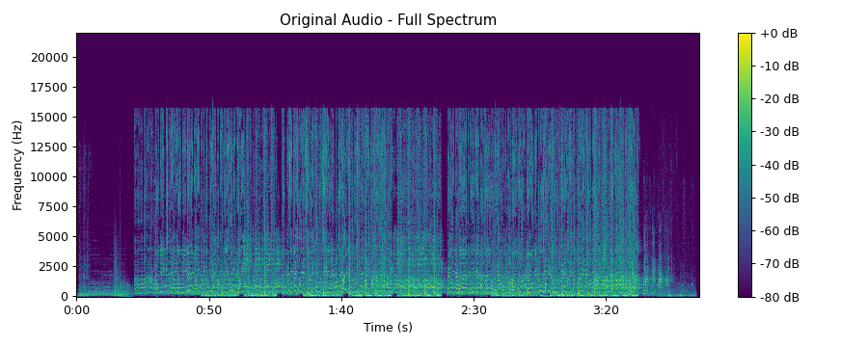
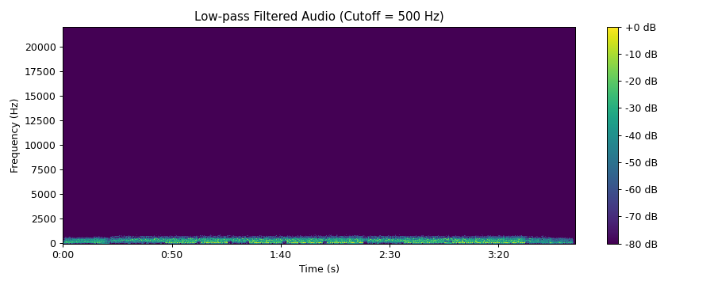
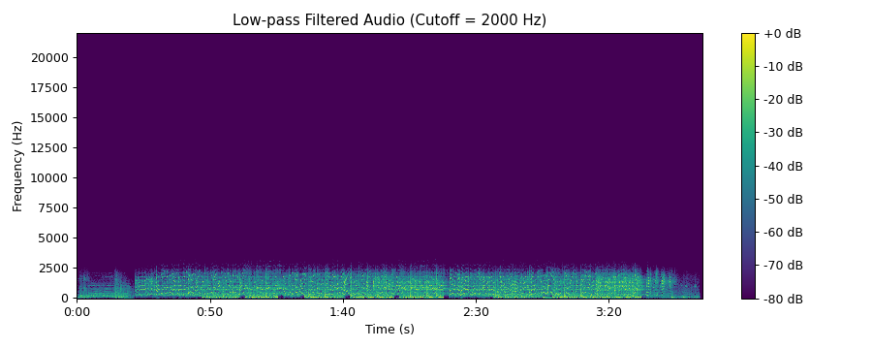
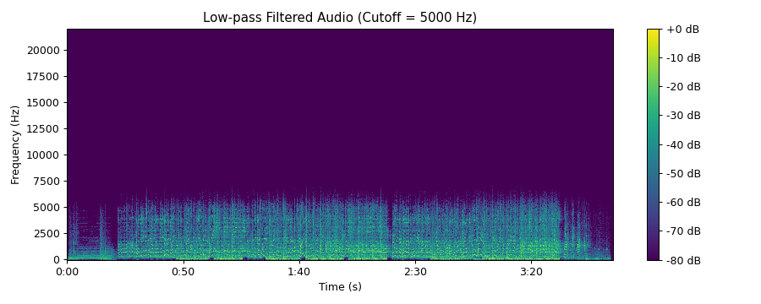
Files saved: lowpass_500Hz.mp3, lowpass_2000Hz.mp3, lowpass_5000Hz.mp3

# Q3 (b) Band-pass / Band-stop filter for vocals and background music
def bandpass_filter(data, lowcut, highcut, fs, order=6):
nyq = 0.5 * fs
sos = butter(order, [lowcut / nyq, highcut / nyq], btype='band', output='sos')
return sosfiltfilt(sos, data)

def bandstop_filter(data, lowcut, highcut, fs, order=6):
nyq = 0.5 * fs
sos = butter(order, [lowcut / nyq, highcut / nyq], btype='bandstop', output='sos')
return sosfiltfilt(sos, data)

# Vocal range is taken as 300 - 3400 Hz
# Band-pass keeps vocals and suppresses background music
vocals_only = bandpass_filter(y, 300, 3400, sr)

# Band-stop removes vocals and keeps background music
background_only = bandstop_filter(y, 300, 3400, sr)

plot_spectrogram(vocals_only, sr, 'Background Music Suppressed (Band-pass 300-3400 Hz)')
plot_spectrogram(background_only, sr, 'Vocals Suppressed (Band-stop 300-3400 Hz)')

# --- Save filtered audio as MP3 ---
sf.write('vocals_only.mp3', vocals_only, sr)
sf.write('background_only.mp3', background_only, sr)
print("Saved vocals_only.mp3 and background_only.mp3")

Output:-
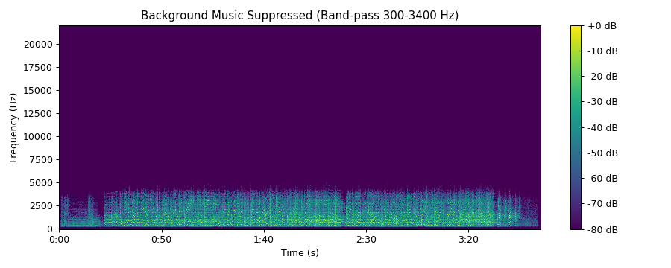
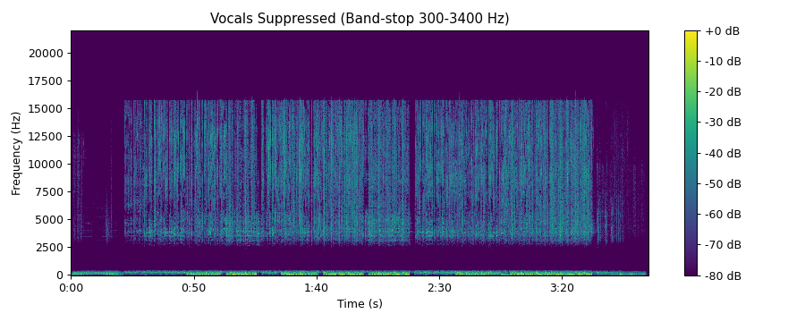
Files saved: vocals_only.mp3, background_only.mp3

Observations (a):-
Song details: The song has a sample rate of 44100 Hz and a duration of 235.29 seconds. In the original spectrogram, most of the energy is in the low frequencies: about 57.5 % of the signal energy lies below 300 Hz, 9.4 % between 300 and 500 Hz and 28.3 % between 500 and 2000 Hz. Only about 4.8 % of the energy is above 2000 Hz, and the spectrogram shows no content above about 15.5 kHz.
Cutoff = 500 Hz: Only a thin low-frequency band remains in the spectrogram and everything above 500 Hz is removed. About 81 % of the original signal level (RMS) is kept, because the song is mainly bass heavy, but the middle frequencies that carry the voice and the melody are lost. The song becomes dull and muffled, with a strong bass and almost no clarity.
Cutoff = 2000 Hz: The content up to about 2 kHz is kept, so the bass and most of the main body of the voice and instruments remain (about 97 % of the original level). The high frequency detail above 2000 Hz is missing, so the song loses brightness, and consonants and the sparkle of the instruments are reduced. The tone is warm but dark.
Cutoff = 5000 Hz: The spectrogram is close to the original up to 5 kHz, and about 99 % of the original level is kept. Only the highest frequencies, such as cymbals and "air", are removed, so the song sounds almost like the original with slightly less brightness.
Effect of cutoff frequency: When the cutoff is increased from 500 Hz to 2000 Hz and 5000 Hz, more of the spectrum passes through, so clarity and brightness improve and the tonal balance moves from bass-heavy to natural. A low cutoff gives a muffled and boomy character, and a high cutoff keeps the original character of the song. Since most of the energy of this song is below 2000 Hz, the level changes very little between 2000 Hz and 5000 Hz, but the detail and brightness are different.

Observations (b):-
Band-pass filter (300 - 3400 Hz): The spectrogram shows content only up to about 4 kHz and the bass below 300 Hz and the high frequencies are removed. The output keeps about 62 % of the original level. The vocals and the middle frequency instruments are kept, so the voice becomes more prominent and the song sounds thinner, like a radio or telephone. The background music is suppressed only partly, because the instruments that lie in the 300 - 3400 Hz range, such as guitar, keys and snare, are still present. The result is saved as vocals_only.mp3.
Band-stop filter (300 - 3400 Hz): The spectrogram shows the bass below 300 Hz and the high frequency content above about 3.4 kHz, with an empty band in the middle. The output keeps about 77 % of the original level, mostly because of the strong bass. The main part of the voice is removed, but some vocal harmonics above 3400 Hz and the low part of the voice remain. The music sounds hollow because the middle frequencies of the instruments are also removed. The result is saved as background_only.mp3.
The vocals and the instruments overlap in frequency, so a simple frequency filter cannot separate them completely. Each filter suppresses one component only partly.

Conclusion
A low-pass filter removes the high frequencies above its cutoff, so a lower cutoff gives a more muffled sound and a higher cutoff keeps the clarity of the song. A band-pass filter in the vocal range emphasizes the vocals and a band-stop filter in the same range reduces them, but since vocals and instruments share the same frequencies, the separation is only approximate.

